

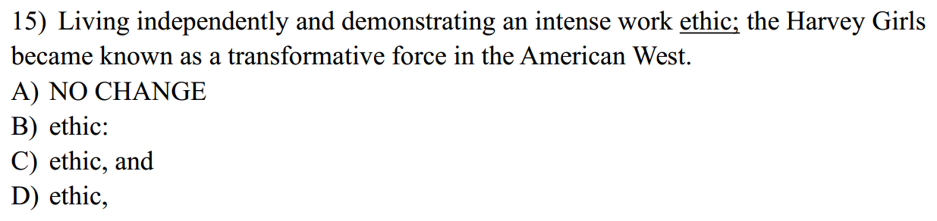

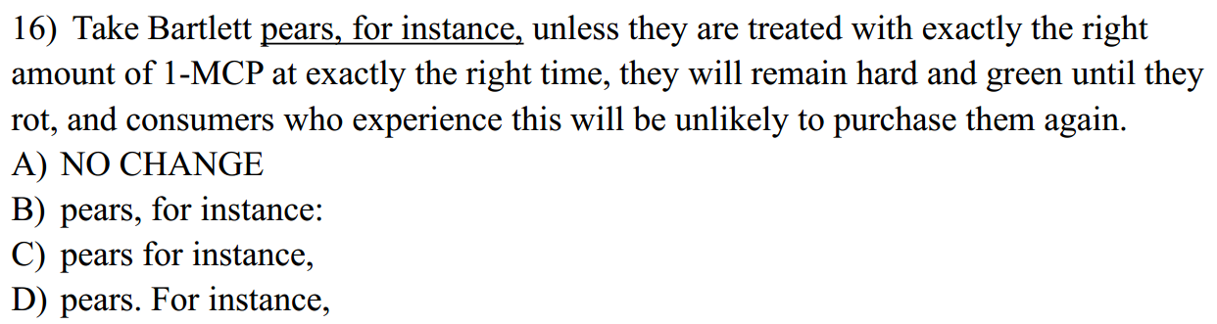

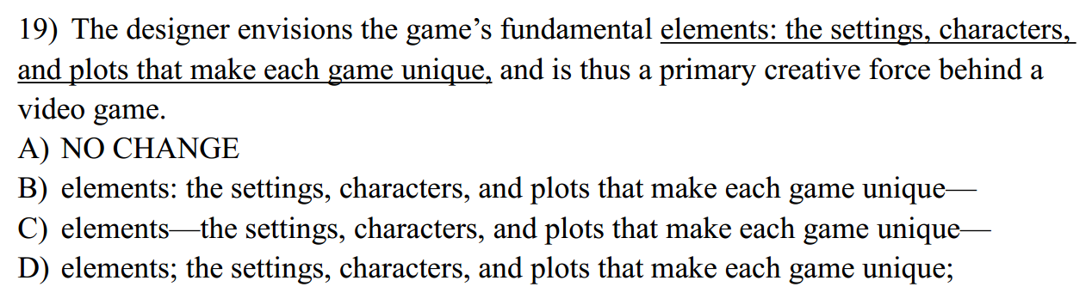

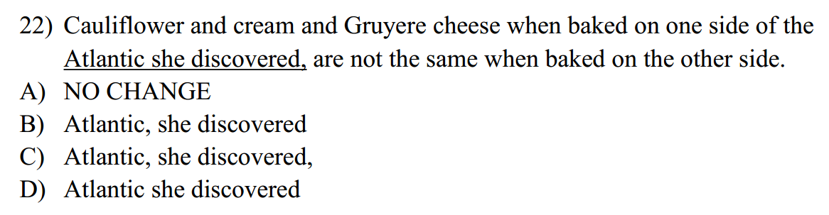

**3, For jointless robots to manipulate the doors, switches, and knobs prevalent in people’s homes and offices, their “limbs” mimic a jointed human.**

1. **NO CHANGE**
2. **the joints of a human**
3. **a human’s limbs’ joint.**
4. **those of a jointed human.**